# FONT INFORMATION:

Ubuntu >>  
<https://fonts.google.com/specimen/Ubuntu?category=Sans+Serif,Display,Monospace>

## Main Menu

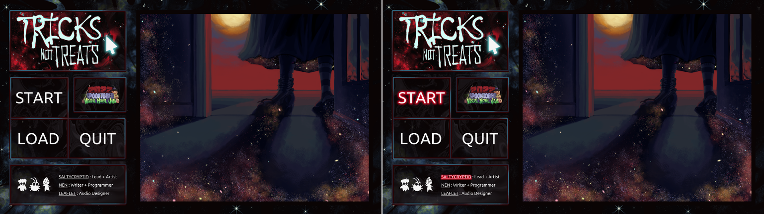

### Menu:

* + 80px
  + #F4F4F4
    - Hover: #D0001F glow

### Credits:

* + 22px
  + #F4F4F4
    - Hover: #D0001F glow

## Game Menu

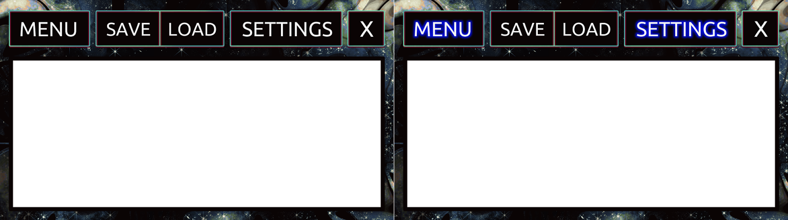

### Menu + Setting:

* + 100px
  + #F4F4F4
    - Selected: #00EFFF
    - Hover: #000ECF glow

### Save + Load:

* + 90px
  + #F4F4F4
    - Selected: #00EFFF
    - Hover: #000ECF glow

### X:

* + 110px
  + #F4F4F4
    - Hover: #000ECF glow

## Settings

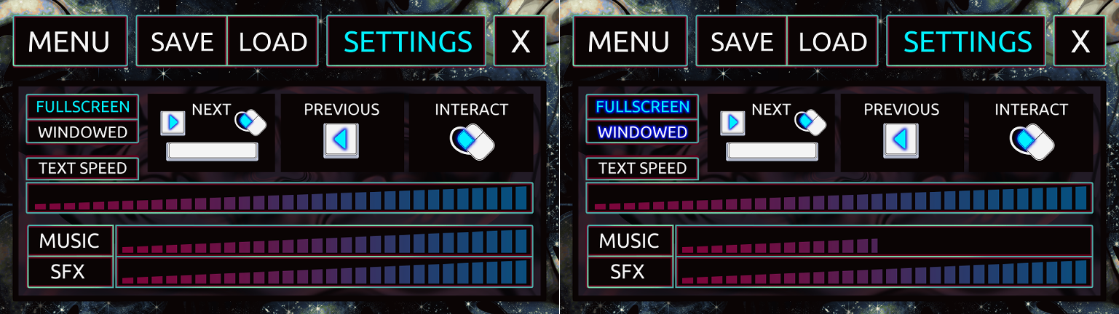

### Screen:

* + 55px
  + #F4F4F4
    - Selected: #00EFFF
    - Hover: #000ECF glow

### Controls:

* + 55px
  + #F4F4F4

### Text:

* + 55px
  + #F4F4F4

### Audio:

* + 70px
  + #F4F4F4

## Files

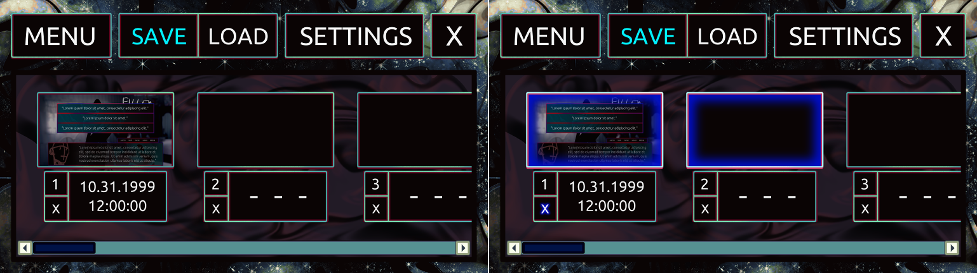

### Number + Info:

* + 60px
  + #F4F4F4

### Blank Dashes:

* + 130px
  + #F4F4F4

### X:

* + 50px
  + #F4F4F4
    - Hover: #000ECF glow

## Dialogue

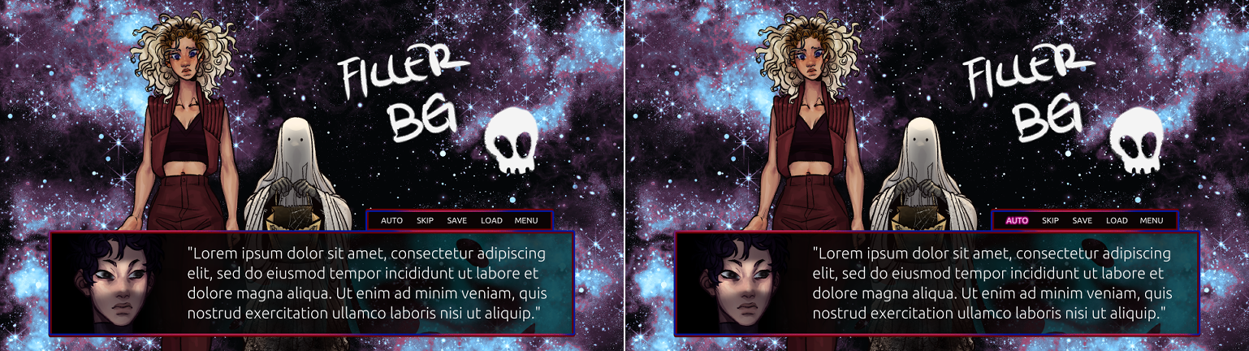

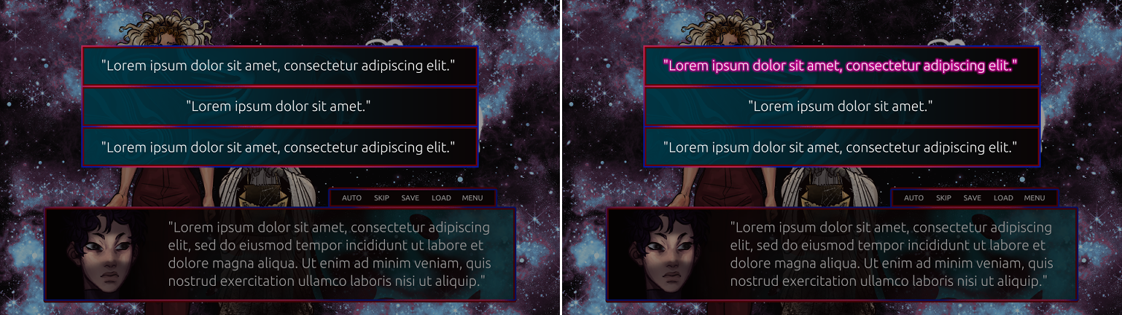

### Text:

* + 48px
  + #F4F4F4

### Menu:

* + 25px
  + #F4F4F4
    - Hover: #BB0087 glow

### Choices:

* + 48px
  + #F4F4F4
    - Hover: #BB0087 glow

## AIM

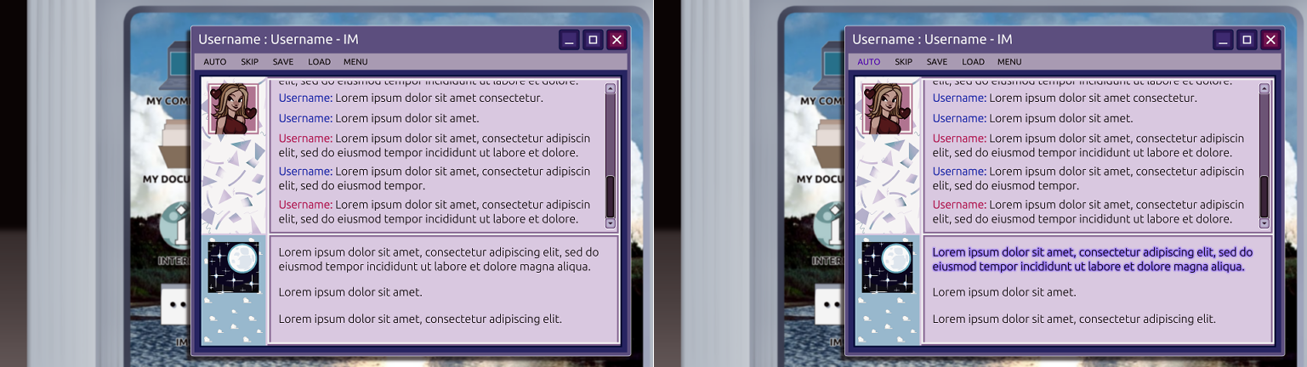

### Title Bar:

* + 40px
  + #F4F4F4

### Menu Bar:

* + 25px
  + #0A0404
    - Hover: #4B00AD

### IMs:

* + 34px
  + #0A0404
    - Bestie Username: #B21E55
    - Player Username: #252FAA

### Choices:

* + 34px
  + #0A0404
    - Hover: #8E6CFF glow